PRESS RELEASE 22 MAY
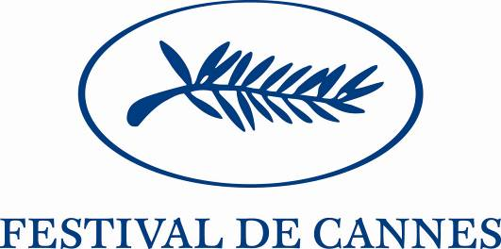

5th EUROPE DAY SATURDAY 26 MAY 2007

AT THE INITIATIVE OF THE EUROPEAN COMMISSION AND THE CANNES FESTIVAL, SPONSORED BY, AND IN THE PRESENCE OF, CHRISTINE ALBANEL, THE FRENCH MINISTER OF CULTURE AND COMMUNICATION AND GOVERNMENT SPOKESWOMAN

Against the background of the new audiovisual legislation adopted by the European Commission on 24 May which will extend the advantages of the "Television without Frontiers" Directive to video and video-on-demand (giving European works more exposure on new media and generating new revenue for film-making), the fifth Europe Day will be held in Cannes under the sponsorship of Brazilian director Walter Salles on the subject "Film-making in Europe: the new rules of the game".

In the presence of Christine Albanel, French Minister of Culture and Communication and Government Spokeswoman, Viviane Reding, European Commissioner for the Information Society and Media, and Gilles Jacob will meet European Union Culture and Audiovisual Ministers around the subject "Film-making in Europe: the new rules of the game", placing the day straightaway in the context of the EU's expressed desire to address concerns expressed by professionals and film-makers. "Promoting dynamic film-making in Europe increasingly involves information and communications technology. This Saturday, on the fifth Europe Day at the Cannes Festival, European Union Culture Ministers and high-profile representatives of the film industry will debate the changes that these new dissemination platforms will bring for the production and financing of cinematographic works. I believe that they will bring something positive, providing a boost for short film production and encouraging the digitalisation and use of film catalogues and likewise the rediscovery of cinema heritage", she said.
For his part, Gilles Jacob believes that people should not view "the arrival of new dissemination platforms as a break with the past but as an enrichment. Digital broadcasting gives us a new opportunity for passing a love of film on to upcoming generations and will complement cinema screenings.
The cinema will always be the place to enjoy films together but it will be complemented by these new vectors."
The Ministers will also take note of the report of the conference organised by the Cannes Festival as a prelude to opening. Entitled "Towards the audiences of tomorrow", this report describes viewers' new practices and asks what their impact will be on the world of film.

The day's programme will be as follows:

Friday 25 May

Europe Dinner presided by Gilles Jacob and Viviane Reding during which the "New Talent in the European Union" prize will be awarded to Saulius Drunga, a Lithuanian scriptwriter/director

22:00 Montée des Marches – the ceremonial entry of the Culture and Audiovisual Ministers with Viviane Reding for the screening of the film Une vieille maîtresse by Catherine Breillat

Saturday 26 May

9:30-12:00 Meeting of European Union Culture Ministers in the presence of Walter Salles and representatives of the industry

12:15 Photo call for the Ministers and the winner of the "New Talent in the European Union" prize, Terrasse Riviera – Palais des Festivals – 3rd floor

12:30 Press Conference with Viviane Reding and the Ministers, during which the conclusions of the meeting will be presented.
Salle des Ambassadeurs – Palais des Festivals – 4th floor

15:00 Meeting with European distributors
Salle des Ambassadeurs

Reminder of Ministers attending:

Christine Albanel (France), Fadila Laanan (Belgium), Claudia Schmied (Austria), Mario Vieira do Carvalho (Portugal), Laine Janes (Estonia), Helena Demakova (Latvia), Jonas Jucas (Lithuania).

Contacts
Cannes Festival
Europe Day Press: Dominique Racle / 06 72 93 04 26
dominiqueracle@wanadoo.fr
Communication: Marie Pierre Hauville 04 92 99 85 67 mphauville@festival-cannes.fr

European Commission
Communication - Press: Nathalie Mercier +33(0) 6 14 61 91 73
Cabinet of European Commissioner for the Information Society: Christophe Forax christophe.forax@ec.europa.eu

