PRESS RELEASE – 7 MAY 2007

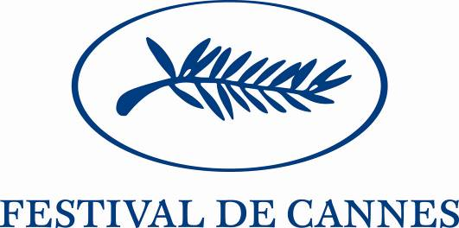

WALTER SALLES, PATRON 5TH EUROPE DAY
AT THE CANNES FESTIVAL

Saturday 26 May 2007

Video via the internet, films by mobile phone: how are new methods of distribution changing the process and the economics of film-making? At the instigation of the European Commission and the Cannes Festival, and under the patronage of the French Minister for Culture and Communication, Viviane Reding and Gilles Jacob have invited European Union culture and audiovisual ministers to discuss the issue with cinema professionals and actors at the Festival on Saturday 26 May.

Brazilian film-maker Walter Salles is patron of the 5th Europe Day at the Cannes Festival.

On 24 May, many European films will be featuring on billboards at the Cannes Film Festival and in the "marché du film"; at the same time, the EU should be adopting new legislation in the audiovisual sphere which will extend the benefits of the "Television Without Frontiers" Directive to video-on-demand and allow for the promotion of European productions using new distribution platforms. Two days later, Viviane Reding (European Commissioner for Information Society and Media) will be in Cannes herself, along with a number of national ministers, to compare notes and share experiences on how audiovisual policy should respond to developments in the making and distribution of films, in particular using the new media – developments which also have implications for the relevant legal provisions: what is the future of the cinema as a venue for watching films, how should films be funded and what is the relationship between film-makers and their audiences (interactivity, new forms of audience involvement, etc.)? These questions will all be central to the ministers' discussions.

Among the ministers who have already confirmed their attendance are: Fadila Laanan, (Belgium ) Claudia Smied (Austria), Laine Janes (Estonia), Theodoros Roussopoulos (Greece), Martà Schneider, (Hungary), Helena Demakova (Latvia) and Jonas Jucas (Lithuania), Mario Vieira do Carvalho,
(Portugal )

The ministerial discussions will follow on from a meeting between film industry professionals at the opening of the Festival on Wednesday 16 May, on "Cinema and the audience of tomorrow". Key figures of European cinema will present the conclusions of that meeting to the ministers on 26 May.

An international patron for the 5th Europe Day: Walter Salles

As someone very aware of the changes in the ways that film is distributed, Brazilian director, script-writer, editor and producer Walter Salles – winner of the Golden Bear at the 1998 Berlin Film Festival with his feature film Central do Brasil (Central Station) and chosen in 2004 for the Cannes Official Selection, in competition, for Diarios de motocicleta (The Motorcycle Diaries) – was keen to contribute by stimulating and taking part in the discussions with the ministers on 26 May.

EUROPE AT THE CANNES FESTIVAL: solid support for film production and distribution.

11 of the films in the various selections were made with European Union support.
This support (despite current budget restrictions) plays a major role today in keeping Europe's audiovisual industry competitive and preserving cultural diversity.

OFFICIAL SELECTION

Auf der anderen Seite des Lebens by Fatih AKIN
Persepolis by Marjane SATRAPI
Import Export by Ulrich SEIDL

"UN CERTAIN REGARD" AWARD

La Soledad by Jaime ROSALES

CRITICS' WEEK

El Orfanato by Juan Antonio BAYONA
Voleurs de Chevaux by Micha WALD

DIRECTORS' FORTNIGHT

Après lui by Gaël MOREL
Garage by Lenny ABRAHAMSON
La Question Humaine by Nicolas KLOTZ
Tout est pardonné by Mia HANSEN-LÖVE
La France by Serge BOZON

Contacts:

Cannes Festival
Europe Day press contact: Dominique Racle / 06 72 93 04 26 (dominiqueracle@wanadoo.fr)
Communications: Marie Pierre Hauville 04 92 99 85 67 (mphauville@festival-cannes.fr)

European Commission
Communications / press: Nathalie Mercier +33(0) 6 14 61 91 73
Ms Reding's private office: Christophe Forax (christophe.forax@ec.europa.eu)

