PRESS RELEASE

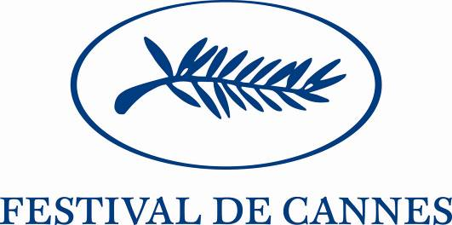

The Opening Forum Wednesday May 16 from 2:30pm to 5:30pm
« Cinema: towards the audiences of tomorrow »

On the opening day of its 60th anniversary, the Festival de Cannes is offering a moment of reflection on the opportunities and challenges of the next decade by holding a conference focused on the evolution of audience practices and on the ties between cinema creation, new promotional and broadcast platforms.

Film industry representatives, new media players, journalists and sociologists will share their experiences and views on how the fast evolving digital economy is shaping new roles for directors, producers and distributors while offering exciting opportunities to creators and audiences. They will debate the following questions:
- From an audience perspective, how has the digital revolution changed the way films are selected, viewed, watched, interpreted and communicated? Will the film theatre continue to be the reference for cinema viewing?
- What will the new medias for cinema and the audiences of tomorrow be: Web 2.0, screenings on demand, DVD-HD, VoD, Social communities, Blogs, Vlogs, Mobile Media, Virtual Worlds...?
- Will tomorrow's marketplace be split between different categories of films: blockbusters, film-events, author films, niche films…? What new promotional tools are being developed and what are the new business models that are emerging? What could the role and the implication of the duo creator-producer be and what will the impact on the role of the distributor be? How can film festivals play a positive role in accompanying creators in this new environment?

Guest Speakers:
Colin Brown, Editor-in-Chief, Screen International will moderate the discussion between the following guest speakers:
Danah Boyd, Ethnographer and researcher of social media networks and doctoral candidate in the School of Information at the University of California-Berkeley (USA)
Emmanuel Ethis, Sociologist in cinema and cinema audience, University of Avignon (France)
Michael Gubbins, Editor, Screen International (United Kingdom)
Thomas Hoegh, Founder and Chairman, Arts Alliance Media (United Kingdom)
Neeraj Roy, CEO, Hungama Mobile (India)
Adrian Sexton, EVP Digital, Participant Productions (USA)
François Yon, Founder and Partner, Films Distribution (France)

The conclusions of the Opening Forum will be reported by Philippe Dana to the European Ministries of Culture on the occasion of the European Day taking place on Saturday May 26.

Salle Buñuel, (Palais des Festivals), Wednesday May 16 2007 from 2:30pm to 5:30pm (Simultaneous translation English-French).With the collaboration of Reed-Midem and Screen International.Press Contact: Dominique Racle, +33 (0)6 72 93 04 26, dominiqueracle@wanadoo.fr.
RSVP requested.

